On the basis of the Act on Cableway Devices for the Transport of Persons (Official Gazette of the Republic of Slovenia, Nos. 126/03, 56/13 and 33/14), the Decision on the Establishment of the Ljubljana Castle Public Institution (Official Gazette of the Republic of Slovenia, Nos. 105/10, 50/16, 6/17 and 9/18), the Decree on the Funicular Railway to the Ljubljana Castle (Official Gazette of the Republic of Slovenia, Nos. 68/05, 99/07 and 10/11), the Concession Agreement for the Construction of the Funicular Railway to the Ljubljana Castle and the Agreement on Implementing the Public Service for the Public Transportation of Passengers on the Funicular Railway (No. 370-298/05-1, dated 30 September 2005) and the Operating Regulations of the Ljubljana Funicular Railway (dated 24 April 2018), the Director of the Ljubljana Castle Public Institute has adopted the following

GENERAL CONDITIONS OF CARRIAGE

I. GENERAL PROVISIONS

Article 1

The General Conditions of Carriage for the transportation of passengers by funicular railway regulate the mutual contractual relationship between the Ljubljana Castle Public Institution as the operator of the funicular railway (hereinafter the Institution) and the passenger. This relationship arises from the purchase or acquisition of a ticket under the conditions and in the manner determined by these General Conditions of Carriage.

The General Conditions of Carriage include provisions on who or what kind of goods can be transported by the funicular railway to the Ljubljana Castle and under what conditions.

The General Conditions of Carriage define the rules for the safe use of the funicular railway and transportation with the funicular railway.

II. TRANSPORTATION OF PASSENGERS

Article 2

The passenger acquires the right to transportation by the funicular railway by purchasing or obtaining a ticket. The right to transportation is not acquired without the purchase or acquisition of a ticket under the conditions and in the manner specified in these General Conditions of Carriage.

Article 3

Passengers are prohibited from entering the cabin and being transported by the funicular railway in the following cases:
- if the passenger is clearly under the influence of alcohol, drugs or other psychoactive substances;
- if the passenger refuses to present a ticket or refuses to pay for the transportation;
- if the passenger’s behaviour represents a threat to public order and peace;
- if the passenger possesses luggage that, in accordance with Article 8 of these General Conditions, is not permitted to be transported;
- if the passenger wants to transport animals on the funicular railway in violation of Articles 7, 9 and 10 of these General Conditions of Carriage.

On being excluded from the cabin in the cases referred to in Paragraph 1 of this article, the passenger is not entitled to a refund of the ticket price.

III. TICKETS

Article 4

Ticket prices are determined by the Decision on the Approval of the Price for Transportation by the Funicular Railway to the Ljubljana Castle (Official Gazette of the Republic of Slovenia, Nos. 42/12 and 7/16) of the City Council of the Municipality of Ljubljana.

The purchase or acquisition of a ticket under the conditions and in the manner determined by these General Conditions of Carriage represents the conclusion of a mutual contractual relationship between the carrier and the passenger, on the basis of which the passenger acquires from the carrier the right to transportation, as well as the right to transport his/her luggage and live animals, according to the published timetable and price list, and under the conditions set out in these General Conditions of Carriage.

Tickets can also be purchased using the Urbana system, which is valid in the area of ​​the Municipality of Ljubljana. The Urbana Card is a means of payment that enables the passenger to purchase a ticket at a point of sale, providing the balance on the passenger’s Urbana Card is sufficient to cover the ticket price.

The Royal Card is an annual ticket that allows the holder an unlimited number of journeys on the funicular railway to the Ljubljana Castle, as well as unlimited visits to the Virtual Castle, the Viewing Tower, the Museum of Puppetry and the Slovenian History Exhibition. By paying the annual membership fee, the holder of the Royal Card acquires the right to an unlimited number of journeys on the funicular railway for a period of one year.

Article 5

Ticket validity is verified by scanning the ticket’s bar code on the reader on the door to the entry platform in the lower and upper stations of the funicular railway.

By purchasing a one-way ticket, the passenger acquires the right to enter and ride from either the lower entry station or the upper entry station of the funicular railway. By purchasing a return ticket, the passenger acquires the right to enter and ride from both the lower entrance station and the upper entrance station of the funicular railway (the ticket allows only one entrance to the lower platform and one entrance to the upper platform).

The operating staff reserve the right to verify tickets.

Article 6

For all other provisions not specified in these General Conditions of Carriage, the currently valid General Terms and Conditions for the Purchase of Tickets and Goods at the Ljubljana Castle Public Institution shall apply. The latter General Terms and Conditions are available at all Ljubljana Castle sales points and at www.ljubljanskigrad.si.

IV. TRANSPORTATION OF LUGGAGE

Article 7

The passenger’s hand luggage and live animals can be transported on the funicular railway together with the passenger under the conditions set out in these General Conditions of Carriage and in accordance with the House Rules of the Ljubljana Castle Public Institution (No. 01-04/2019 of 3 May 2019) .

Article 8

Hand luggage may be carried free of charge. Hand luggage includes items weighing up to 15 kg and of smaller dimensions (handbags, small packages or packages).

The passenger may not transport the following items as hand luggage:
- weapons, sharp objects, and flammable, explosive or radioactive objects, as well as other objects or substances whose properties may pose a danger to passengers and the cabin;
- objects whose transportation is prohibited by legal regulations or regulations on public order and peace;
- other luggage that could cause injury or damage to other passengers or the cabin.

Baggage that could obstruct other passengers may not be transported on the funicular railway.

V. TRANSPORTATION OF ANIMALS

Article 9

It is permitted to transport guide dogs, service dogs and dogs on leashes on the funicular railway, providing that the dogs are wearing a muzzle or are in a basket. Dogs are transported free of charge.

Guide dogs and service dogs must be marked with visible tags (bib or collar badge). The use of a muzzle is preferred.

Article 10

The transportation of other small animals is only permitted if the animal is in a cage and is transported in such a way that it does not hinder other passengers, and that all hygiene and sanitation regulations are met.

VI. OBLIGATIONS AND RESPONSIBILITIES OF THE PASSENGER

Article 11

The obligations and responsibilities of the passenger are as follows:
- passengers are permitted to enter and exit the funicular railway only at the designated points in the lower and upper funicular railway stations;
- passengers must enter and exit according to the markings displayed or following the instructions of the operating staff;
- passengers can hold the handrails during transportation;
- passengers must not pollute or destroy the funicular railway cabin, and shall be liable for any damage caused;
- passengers must not lean on the doors or open them by force;
- passengers are not permitted to drink, eat, smoke, etc. in the cabin

Article 12

In order to enter the cabin, children aged up to seven (7) years must be accompanied by:
- an adult or
- a young person of at least (10) years of age, with the permission of the young person’s parents or legal guardian.
Entering the cabin with a bicycle, skateboard, electric scooter, roller skates or rollerblades is prohibited.

VII. RESPONSIBILITIES OF THE OPERATOR

13. Article 13

The operator is not responsible for loss and/or damage arising due to the death, impairment to health or injury of a passenger, if it is proven that the loss and/or damage was caused by the actions of the passenger or by an external cause that could not be expected, avoided or prevented – force majeure.

Article 14

The operator is not responsible for loss and/or damage arising from the loss or damage of hand luggage or other luggage.

VIII. FOUND ITEMS

Article 15

In accordance with the Rules on Handling Found Items (Official Gazette of the Republic of Slovenia, No. 90/15) and the internal Rules on Handling Found Items (of 11 April 2016), found items are stored in the Info Centre, where a Register of Found Items is maintained.

Employees of the Funicular Railway Operation Service are obliged to inspect the cabin after each journey and hand over found items to the Info Centre.

IX. COMPLAINTS

Article 16

All complaints must be submitted in writing in accordance with the General Terms and Conditions for the Purchase of Tickets and Goods at the Ljubljana Castle Public Institution. Passengers can submit written complaints to the funicular railway operator.

Ljubljana Castle Public Institution
Director
Mateja Avbelj Valentan
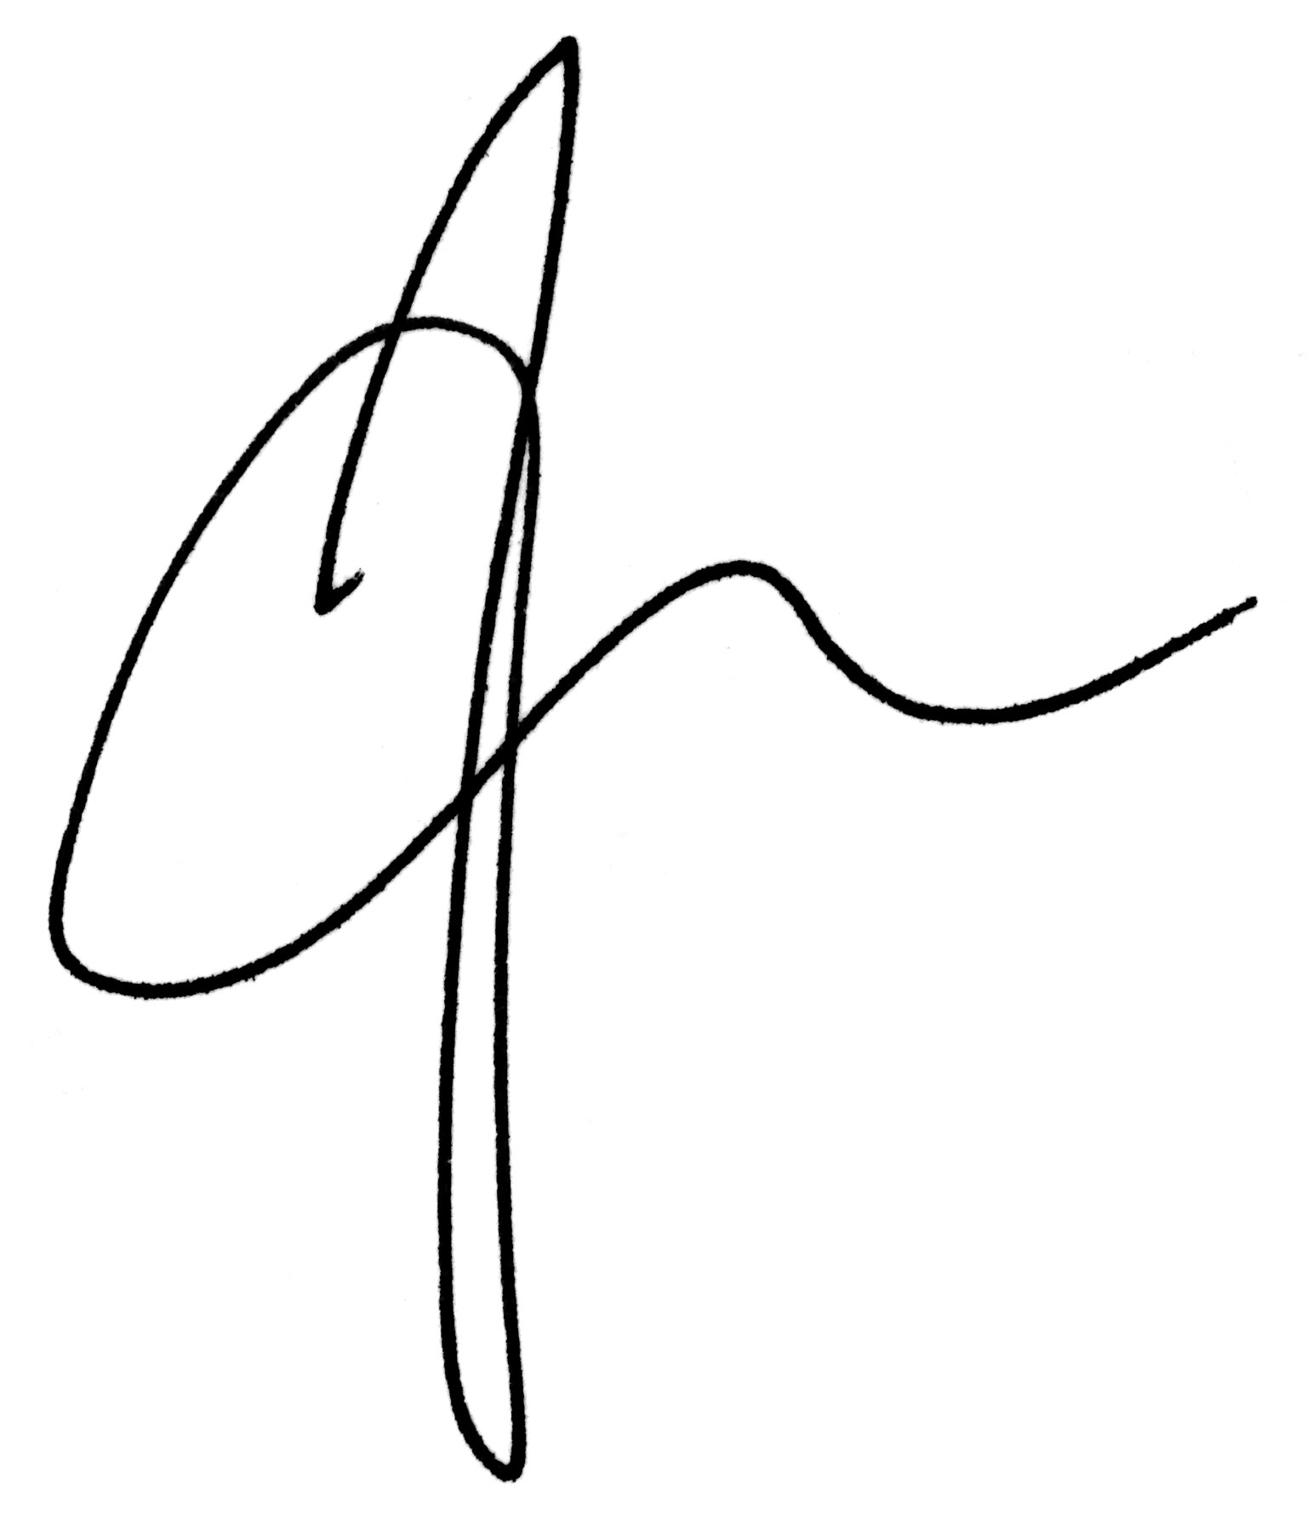
Number: 01-06/2019
Date: 01 October 2019

